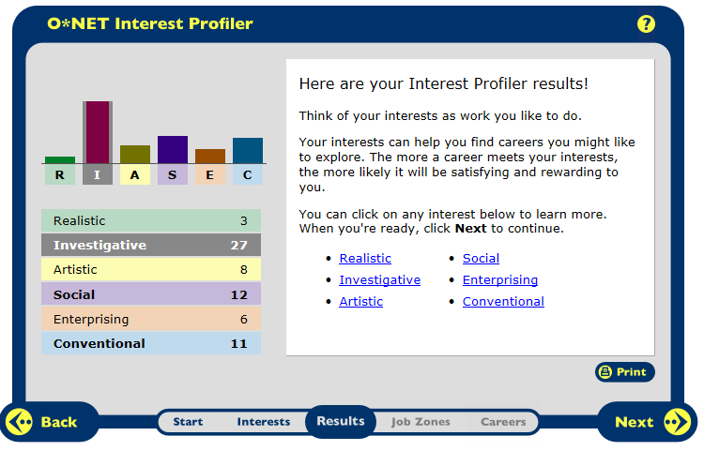
The top three results from the Interest Profiler were that I am interested in a career that is investigative, social, and conventional. Overall, I think that the Profiler was accurate in predicting my interests. I am very interested in investigation. This was my highest score on the Interest Profiler. I like to know and figure out the reasons behind why certain things occur. I also like to do hands-on activities that prove certain ideas. I am also very strong in math and science.
Social was my second highest result. This is because I like working with people. I don’t like working all alone on hands-on assignments. I like to help people and I am a good advice giver. I never fail to give my opinion on any given subject. One reason that this interest would not fit me is the fact that I don’t like working with kids. I don’t have the patience to teach, or take care of them. I do, however, enjoy working with other people my age or older.
Conventional was my lowest interest result. This is because I always like to complete my assignments neatly and correctly. I am also a perfectionist, so I pay attention to details. I like following a certain procedure on projects or labs instead of making up my own procedures and being creative. One thing that contradicts me is the fact that conventional interests revolve around details and information, instead of ideas, like what investigation revolves around. This means that my interests fit somewhere between ideas and details.

Careers to Research further:
Investigative
- Chemist
- Forensic Science Technician
- Medical Scientist
- Physician
Social
- Nutritionist
- Occupational Therapist
Conventional
- Financial Analyst
- File Clerk

Career Project Data
 | Chemist | Forensic Technician | Medical Scientist | Physician
Definition of Job | research, test and analyze substances, develop new products, write and present report | collect and analyze evidence to help solve crimes. Sometimes required to present information in court. | investigate and analyze human diseases in order to come up with ways to improve human health | diagnose and treat the injuries and illnesses of patients
Related Fields | Biochemistry, chemical engineering, teaching | Biochemistry, detectives, medical scientist | Biochemists, physicians, epidemiologists | chiropractors, optometrists, and dentists.
Personality Type | Investigative | Investigative | Investigative | Investigative
Minimum Education | Bachelor’s degree; job training | Bachelor’s degree in natural science; extensive training | Ph.D. is biology or other life science | 4 years of undergraduate, 4 years of medical school, and 3-8 years of internship, residency and a physician license.
Technology Skills | computers and highly advanced technology in labs. | Advanced technology; be able to use all of the machines that run the tests | advanced machinery to run tests; Periodic training in new technology | Simple office technology such as stethoscope; computers and software.
Median Salary | $68,320 | $51,570 | $76,700 | $202,392.
Projected Growth | 4% | 19% | 36% | 24%
Places the Hire | laboratories, pharmaceutical/ medicine manufacturing, research, and universities. | state or local governments, hospitals, investigative services, and medical or diagnostic laboratories. | universities, in medical and pharmaceutical manufacturing, research, and hospitals. | hospitals, group clinics, and health care organizations
Work Conditions | work in lab; exposed to some hazardous materials; work full time with regular hours; long hours are not uncommon. | crime lab; work full time with regular hours, but may be required to work over-time, staggered days or be on call | work in offices or laboratories. They work full time | work in both offices and hospitals; Hours long and irregular; overnight shifts; need to be on call
Union | No | No (unless in government lab) | Yes, if at a public hospital | Yes, if at a public hospital
Promotions | With a Ph.D. can lead research and control projects. | With experience and an advanced education can become director of lab | With experience can become head of research | own their own practice; and become certified specialized areas with more education
Colleges | College of the Holy Cross  Stonehill College  Roger Williams University | University of Rhode Island  Emmanuel College | Stonehill College  College of the Holy Cross  Roger Williams University | Roger Williams University  College of the Holy Cross  Stonehill College

Career Project Data
 | Nutritionist | Occupational Therapist | Financial Analyst | File Clerk
Definition of Job | guide people to live a healthy life-style through their food choices | treat patients with injuries and disabilities through physical and other therapeutic activity | guide businesses and individuals making investments by evaluating their financial situation | maintain records, collect data and information, and help answer the questions of clients
Related Fields | Health educator | physical therapy, athletic trainer, and recreational therapy | budget analysts, financial managers, and personal financial advisors | are human research specialists, receptionists, and financial clerks
Personality Type | Social | Social | Conventional | Conventional
Minimum Education | bachelor’s degree in dietetics or food in nutrition; hours of training; license of certification. | master’s degree in occupational therapy | bachelor’s degree, license and certification. | high school diploma; training needed
Technology Skills | Simple office technology; electronic files | Simple office technology; keeping patient files | latest computer technology; understand and use data bases and computer software to research and keep files | Basic skills needed; search through files to retrieve information; use many data bases.
Average Salary | $53,250 | $72,320 | $74,350 | $29,990
Projected Growth | 20% | 33% | 23% | 7%
Places the Hire | hospitals, cafeterias, nursing homes, schools, and offices | hospitals, offices, nursing care facilities, home health care services, or individual and family services | insurance carriers, depository credit intermediation, securities and commodity contracts intermediation and brokerage, and management of companies and enterprises | medical offices, government agencies, law offices, and private businesses
Work Conditions | Environment laid back and others hectic; work full time or part-time or are self-employed | work full time, and may need to work nights and weekends for the needs of patients | office buildings; work full time; Many work 50-70 hours a week | work in some type of office; work full time or part-time in places such as hotels, motels, and resorts
Union | Yes, if at a public hospital or school | Yes, if at a public hospital or school | No | No
Promotions | Can start own practice or become specialized in certain areas with more education | become the head of a practice; start their own practice, or become more specialized | portfolio managers and fund managers that supervise and manage large investments | promoted to a more specialized type of clerk, such as financial, or become a financial analyst with education
Colleges | Johnson and Wales University  UMass Amherst | Boston University  Worcester State University | Providence College  Bridgewater State | College not required

